GRAPHS IN EVERYDAY LIFE ASSIGNMENT

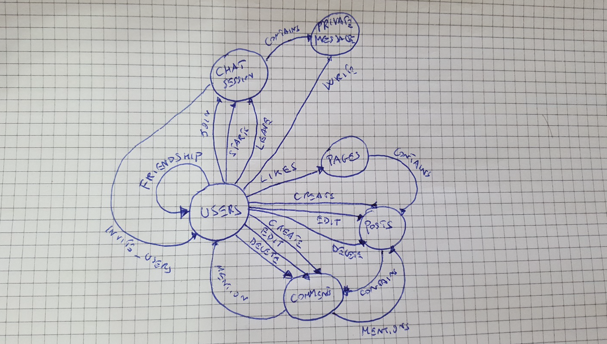

I thought a simple Social Network with a basic functionality such as create posts, comments them, ask friendship, chat and like pages.

Below is a list of nodes and edges :

|  |  |
| --- | --- |
| ID | NODE |
| 1 | Users |
| 2 | Pages |
| 3 | Posts |
| 4 | Comments |
| 5 | Chat Sessions |
| 6 | Private Messages |

|  |  |  |
| --- | --- | --- |
| SRC_ID | DST_ID | EDGE_TYPE (E) |
| 1 | 1 | Friendships |
| 1 | 2 | Likes |
| 1 | 3 | Creates |
| 1 | 3 | Edits |
| 1 | 3 | Deletes |
| 1 | 4 | Creates |
| 1 | 4 | Edits |
| 1 | 4 | Deletes |
| 1 | 4 | Likes |
| 1 | 5 | Starts |
| 1 | 5 | Leaves |
| 1 | 5 | Joins |
| 1 | 6 | Writes |
| 2 | 3 | Creates |
| 2 | 3 | Edits |
| 2 | 3 | Deletes |
| 2 | 4 | Creates |
| 2 | 4 | Edits |
| 2 | 4 | Deletes |
| 4 | 1 | Mentions |
| 4 | 2 | Mentions |
| 5 | 1 | Invite |
| 5 | 6 | Contains |
| 2 | 3 | Contains |
| 3 | 4 | Contains |

A Social Network like this could provide tons of questions and answers, for example:

* Who is the influencer of the network? Users with lots of friends and pages with lots of likes are the best candidates to be defined as such. A useful metric is Degree of Centrality.
* What is the trending topic/ posts? We can retrieve the trending topic based on the number of interactions such as comments and likes and compute TF-IDF for each returned comment.
* What are the most active Users? Users (or pages) with N likes or comments X Day is very active.
* What are the suggested users for each user? We should find the closest non friend neighbours and suggest to each user respectively.